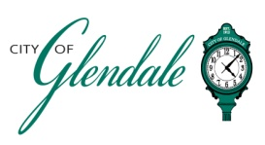
TENTATIVE AGENDA
MARCH 12, 2025 6:00 P.M.
ARCHITECTURAL REVIEW BOARD

The Architectural Review Board will convene at the City of Glendale Auditorium which will be open to the public.

- MEETING CALLED TO ORDER

- ROLL CALL

- APPROVAL OF MINUTES: FEBRUARY 12, 2025

- REVIEW OF PLANS FOR BASEMENT REPLACEMENT AND ONE-STORY ADDITION, DALE MESSEY, 6 HIGHLAND PL.

- REVIEW OF PLANS FOR CONSTRUCTION OF A NEW HOME, SCOTT DUNAVANT, 1240 N. SAPPINGTON RD.
- MISCELLANEOUS

- ADJOURNMENT

________________________
Gabrielle Macaluso POSTED: ___________________, 2025
Deputy City Clerk

